EchoWave-Coursework-DistributedAlgorithm-master

JIE XU

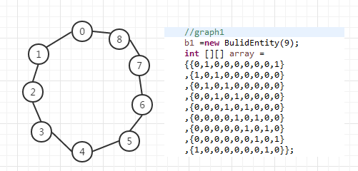
Iterations total | token | K | Decide node | Theoretical token
70 | 18 | 14 | 0 | 18
78 | 18 | 20 | 7 | 18
99 | 18 | 27 | 4 | 18

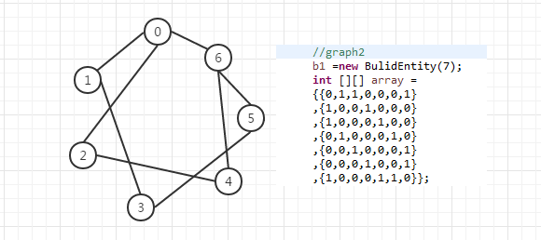
Iterations total | token | K | Decide node | Theoretical token
37 | 16 | 14 | 4 | 16
39 | 16 | 12 | 4 | 16
53 | 16 | 20 | 5 | 16
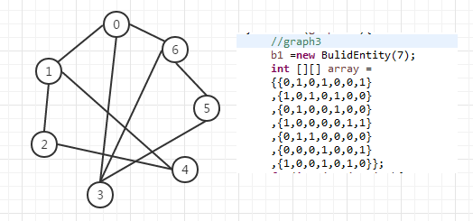
Iterations total | token | K | Decide node | Theoretical token
29 | 18 | 10 | 5 | 18
19 | 18 | 10 | 0 | 18
39 | 18 | 11 | 1 | 18
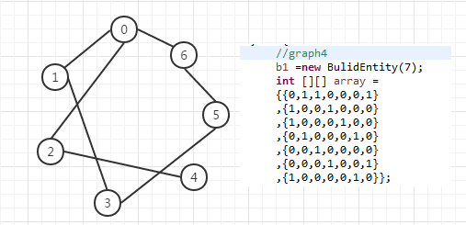
Iterations total | token | K | Decide node | Theoretical token
31 | 14 | 10 | 3 | 14
27 | 14 | 10 | 5 | 14
32 | 14 | 10 | 1 | 14
1, network structures used during the executions is shown above.
2, Tables detailing a number of executions for each structure created is shown above.
3, Compare with graph 2 and graph 4 we can see that : a fully connected structure required not less iterations than the connected, but not fully, connected ones.

